EC2 Deploy Jenkins on AWS

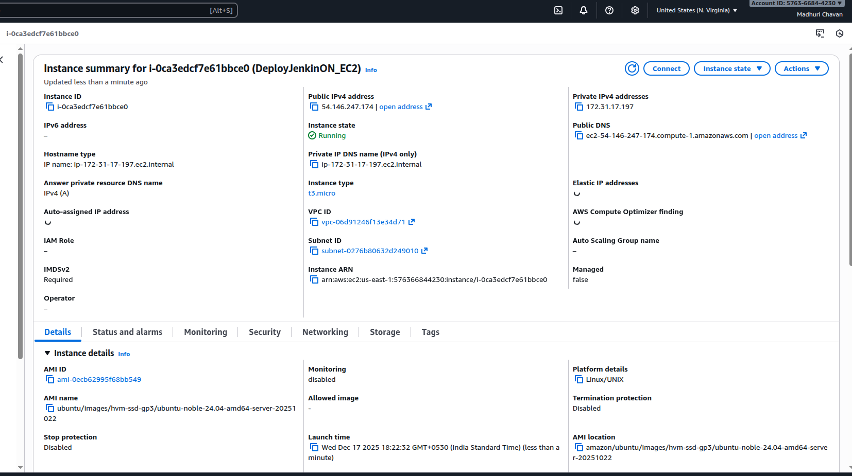



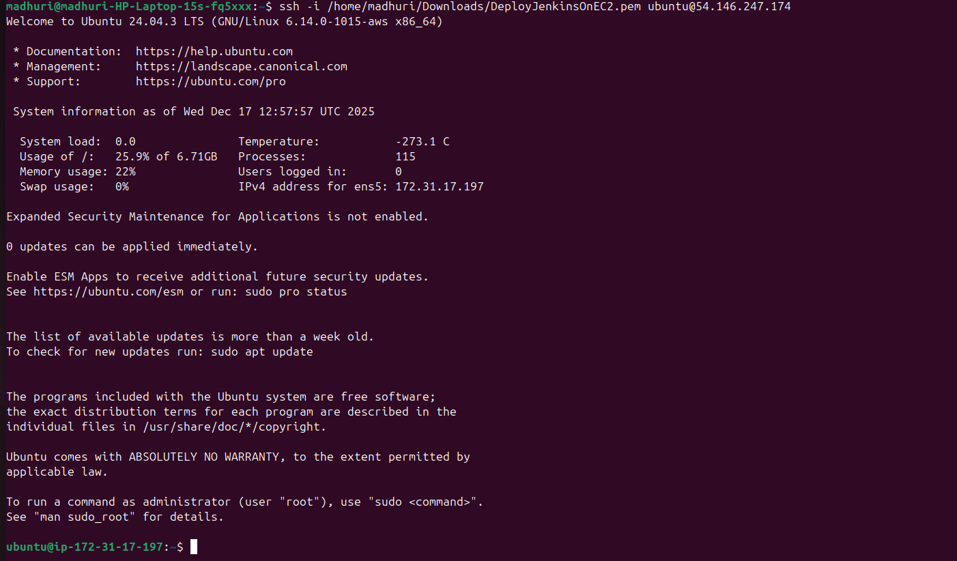

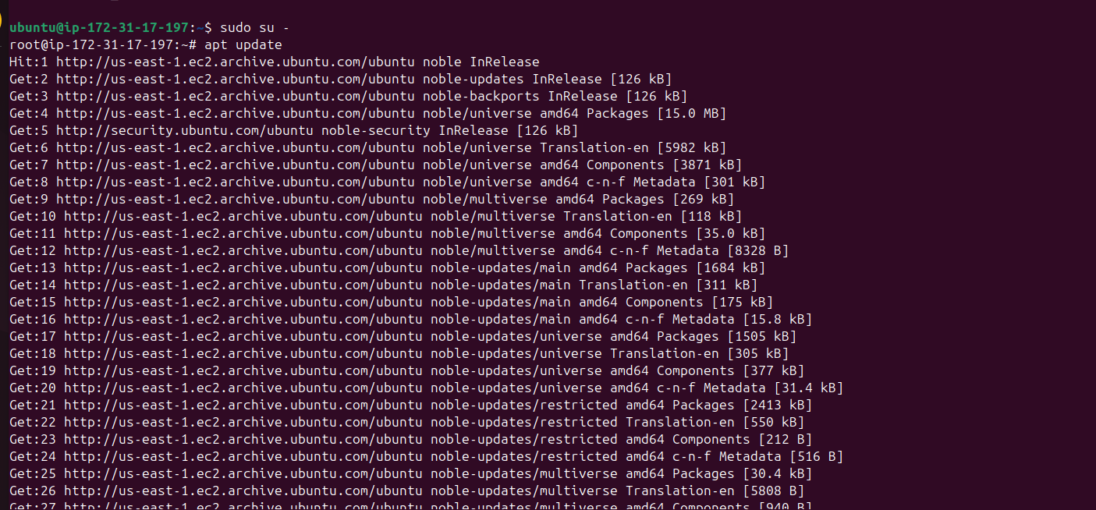

sudo apt install openjdk-17-jdk -y

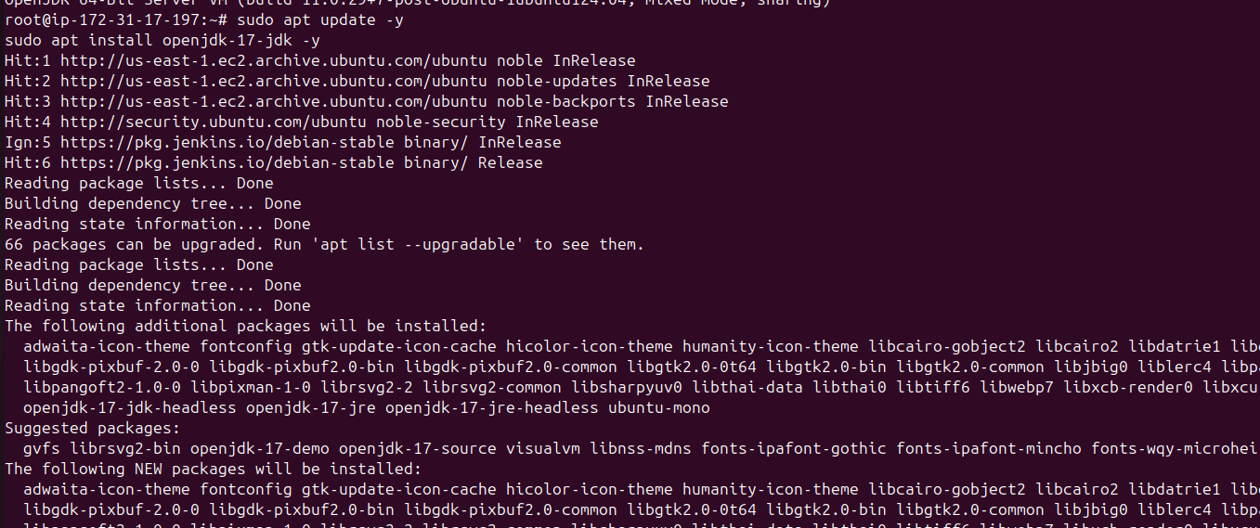

java -version

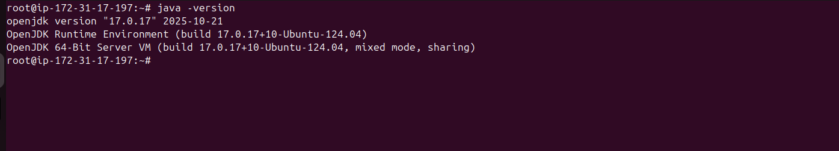

curl -fsSL https://pkg.jenkins.io/debian-stable/jenkins.io-2023.key | sudo tee \
/usr/share/keyrings/jenkins-keyring.asc > /dev/null

echo deb [signed-by=/usr/share/keyrings/jenkins-keyring.asc] \
https://pkg.jenkins.io/debian-stable binary/ | sudo tee \
/etc/apt/sources.list.d/jenkins.list > /dev/null

sudo apt update -y
sudo apt install jenkins -y

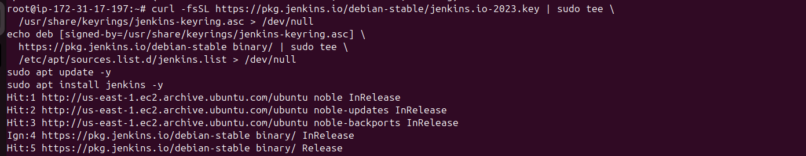

sudo systemctl start jenkins
sudo systemctl enable jenkins

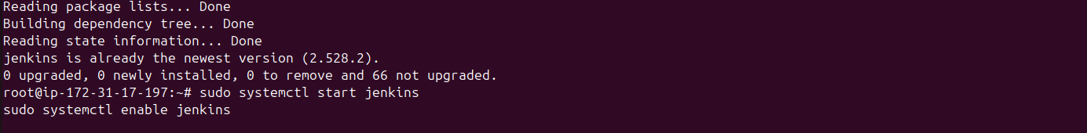

sudo systemctl status jenkins

